Quickdress: Requirements Specification
Milestone 1 · Scoping, Requirements and Architecture · October 13, 2026
Prepared by Omar Hassan
Team: Aya Noaman, Malk Metwally, Nada Salem, Marwan Abouelfotuh, Omar Hassan

Contents
- System overview
- Product backlog
- Scope of the project
- Use cases
- Global, cultural, social, environmental, economic, public health, safety and welfare considerations
- Conclusion

1 System overview
Quickdress is an iOS app that photographs a user's wardrobe once, then recommends a complete outfit from those clothes every morning, matched to the day's weather and calendar.

1.1 What it is
The user captures each clothing item with the phone camera. Quickdress stores the item with its attributes (type, colour, warmth, formality, comfort). Each morning the app presents one outfit for the day; the user can swap a single piece or request a new combination. Everything runs on the device: SwiftUI, SwiftData, and a recommender that starts as a rule-based scorer and can later use an on-device Core ML model. An optional step that asks Google's Gemini model for a suggestion is off by default and runs only if the user turns it on (FR-22).

1.2 Purpose and the problem it solves
Choosing clothes is a daily, repeated decision that costs time and causes decision fatigue. People repeat the same few outfits, forget items they own, and dress for the wrong weather or occasion. Quickdress removes the decision: it turns a 10-minute morning choice into a 10-second confirmation, using only clothes the user already owns.

1.3 Users
User | Need | How Quickdress serves it
University students | Little time in the morning, variable daily schedule (lectures, gym, events) | Calendar-aware outfit each morning
Young professionals | Dress codes that change by meeting; want to avoid repeating outfits in front of colleagues | Formality filter, repeat tracking
People with decision anxiety | Too many choices causes stress | One recommendation, not a catalogue
People unsure about colour matching (including colour-vision deficiency) | Cannot judge which colours go together | Colour matching handled by the recommender

1.4 Stakeholders
Stakeholder | Interest
End users (above) | A fast, trustworthy daily recommendation; privacy of wardrobe photos and calendar
Development team (Aya, Malk, Nada, Marwan, Omar) | Deliverable scope within the course timeline; learning Swift
Course instructor and TAs | Clear requirements, sound architecture, evidence of process (Jira, GitHub)
Apple (platform owner) | App Store guidelines, permission rules for camera, calendar and location
Weather data provider (Apple WeatherKit; Open-Meteo as a backup) | API usage within quota and terms
Google (Firebase AI Logic and the Gemini API) | Only if the opt-in AI step (FR-22) is built: API usage within quota and terms. It receives anonymised item attributes, never photos, calendar text or location.

1.5 Motivation
Existing closet apps (Cladwell, Whering, Acloset) are digital catalogues: they store clothes but still leave the choosing to the user. Quickdress differs in two ways:
- Custom filters that reflect the user's actual day: weather, mode of transport (walking in heat vs. air-conditioned car), comfort level.
- Calendar integration, so a 9 a.m. presentation and a 6 p.m. gym session both shape the recommendation.
The team's background in programming, databases and UI design, plus prior mobile development exposure, makes a native iOS implementation realistic within the course timeline.

2 Product backlog
The backlog lists everything the team has identified, including items that will not fit this term. Priority follows MoSCoW; Section 3 draws the implemented scope from the Must and Should rows.

2.1 Functional requirements
ID | Epic | Requirement | Priority
FR-01 | Wardrobe capture | The user shall add a clothing item by taking a photo or choosing one from the photo library. | Must
FR-02 | Wardrobe capture | The system shall store each item with attributes: category (top, bottom, outerwear, shoes, accessory), colour, warmth level, formality level, comfort level, and season. | Must
FR-03 | Wardrobe capture | The user shall be able to edit or delete any stored item. | Must
FR-04 | Wardrobe browsing | The user shall be able to view the wardrobe as a grid, filtered by category and colour. | Must
FR-05 | Daily outfit | The system shall generate one complete outfit (top, bottom, shoes, plus outerwear when needed) each day from the user's own items. | Must
FR-06 | Daily outfit | The user shall be able to replace any single piece in the recommended outfit with an alternative suggestion. | Must
FR-07 | Daily outfit | The user shall be able to request a completely new outfit. | Must
FR-08 | Weather | The system shall fetch the day's forecast for the user's location and use temperature and precipitation when choosing warmth level and outerwear. | Must
FR-09 | Daily outfit | The user shall be able to mark an outfit as worn, and the system shall avoid repeating a worn outfit within a configurable number of days. | Should
FR-10 | Custom filters | The user shall be able to set daily filters: mode of transport (walking, public transport, car), comfort priority, and formality override. | Should
FR-11 | Calendar | The system shall read the day's events from the iOS Calendar (with permission) and raise the outfit's formality when an event is tagged formal, such as a presentation or interview. | Should
FR-12 | Saved outfits | The user shall be able to compose and save their own outfits for the recommender to reuse. | Should
FR-13 | Wardrobe capture | The system shall suggest the category and dominant colour of a photographed item automatically, which the user may correct. | Should
FR-14 | Daily outfit | The system shall send a morning notification at a user-chosen time with the day's outfit. | Could
FR-15 | Insights | The system shall show which items have not been worn in the last 30 and 90 days. | Could
FR-16 | Daily outfit | The user shall be able to rate a recommended outfit, and the recommender shall learn from ratings. | Could
FR-17 | Wardrobe capture | The system shall remove the photo background so items display consistently. | Could
FR-18 | Travel | The user shall be able to generate a packing list for a trip of N days at a destination. | Won't (this term)
FR-19 | Social | The user shall be able to share an outfit image with friends. | Won't (this term)
FR-20 | Laundry | The system shall track items currently in the laundry and exclude them from recommendations. | Won't (this term)
FR-21 | Multi-device | The wardrobe shall sync across the user's devices via iCloud. | Won't (this term)
FR-22 | AI suggestions | The user shall be able to turn on AI suggestions. When they are on, the system may ask an external model (Gemini) for an outfit, sending only anonymised item attributes and the day's conditions. | Could

2.2 Non-functional requirements
ID | Quality | Requirement | Priority
NFR-01 | Performance | The daily outfit screen shall be visible within 2 seconds of opening the app on an iPhone 12 or newer. | Must
NFR-02 | Privacy | Wardrobe photos, item data and calendar information shall be stored and processed on the device only; no personal data leaves the phone without explicit user consent. | Must
NFR-03 | Availability (offline) | Wardrobe browsing and outfit generation shall work with no network connection, using the last fetched forecast. | Must
NFR-04 | Usability | A new user shall be able to add their first item and receive an outfit within 5 minutes, without instructions. | Must
NFR-05 | Performance | Generating an outfit for a wardrobe of up to 200 items shall take under 1 second. | Should
NFR-06 | Reliability | The app shall not lose any stored item or photo across app updates or force-quits. | Should
NFR-07 | Security | Access to the Camera, Photos, Calendar and Location shall each be requested only when first needed, with an explanation, and the app shall remain usable if any permission is denied. | Should
NFR-08 | Maintainability | The recommendation engine shall be behind a single interface so the on-device model can be swapped for an API-based model without changing the UI. | Should
NFR-09 | Accessibility | All screens shall support VoiceOver labels and Dynamic Type up to the Accessibility XL size. | Could
NFR-10 | Compatibility | The app shall support iOS 17 and later. | Could
NFR-11 | Localisation | UI strings shall be externalised so Arabic can be added without code changes. | Could

3 Scope of the project
The team will implement the 13 functional requirements FR-01 to FR-13 and the 8 non-functional requirements NFR-01 to NFR-08. FR-22 is attempted in Sprint 3 only if capacity remains after FR-12 and FR-13. Everything else in the backlog is deferred.

3.1 Functional requirements in scope
Group | Requirements | Why in scope
Wardrobe capture and browsing | FR-01, FR-02, FR-03, FR-04 | Without a stored wardrobe nothing else works; this is the foundation.
Daily outfit | FR-05, FR-06, FR-07 | The core promise of the product: open the app, see today's outfit.
Weather | FR-08 | The first custom filter and the simplest external integration (WeatherKit is a first-party Apple API).
Context filters | FR-09, FR-10, FR-11 | These are the differentiators named in the pitch: no repeats, transport and comfort filters, calendar awareness.
Stretch | FR-12, FR-13, FR-22 | Saved outfits, automatic attribute suggestion and the opt-in Gemini step improve the experience, but the app is complete without them. Built only if Sprint 3 has capacity.

3.2 Non-functional requirements in scope
NFR-01 to NFR-08: performance (2 s to first screen, 1 s to generate), on-device privacy, offline operation, 5-minute first-run usability, data durability, permission handling, and a swappable recommendation engine. NFR-09 to NFR-11 (accessibility, iOS version floor, localisation) are followed as good practice but not formally tested this term.

3.3 Out of scope this term
FR-14 to FR-21: notifications, wear insights, rating-based learning, background removal, travel packing, social sharing, laundry tracking and iCloud sync. Each needs either a server, extra ML work, or an additional Apple framework, and none is required to prove the concept.

3.4 Why the scope is achievable
The scope is split into three sprints, one per remaining course milestone, and each sprint ends with a working app that can be demonstrated. The riskiest work (the recommender, Sprint 2) is placed in the middle so Sprint 3 remains as buffer.
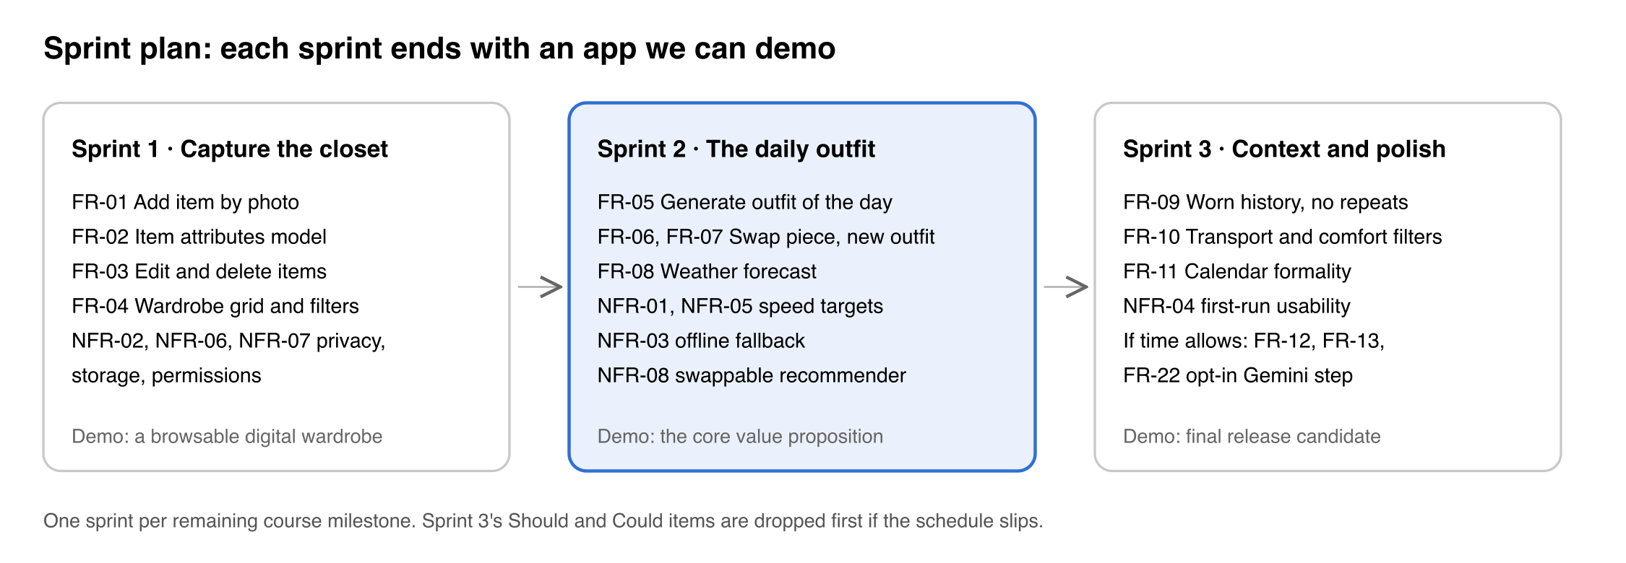
Figure 1. Sprint plan: three sprints, one per remaining milestone.
Five team members give roughly 10 person-weeks per sprint. Sprint 1 is mostly SwiftUI and SwiftData CRUD, well documented and suitable for a team learning Swift. Sprint 2 is the recommender, which in its first version is a rule-based scorer over item attributes (warmth vs. temperature, formality vs. calendar, colour compatibility table) rather than a trained model; this removes the ML risk from the critical path, and the on-device Core ML version can replace it behind the same interface (NFR-08). Sprint 3 adds filters that are mostly extra scoring rules plus one framework integration (EventKit) and, if capacity remains, the opt-in Gemini step behind the same interface (FR-22).
Open question for the team: confirm the number of sprints and their dates from the course schedule so the plan above can carry real dates.

4 Use cases
Quickdress has one primary actor, the User, and three secondary actors that the system calls: Apple WeatherKit, the iOS Calendar (EventKit) and, only when the user has turned on AI suggestions, Google's Gemini model through Firebase AI Logic. The diagram covers the in-scope requirements FR-01 to FR-11 and the stretch requirement FR-22.
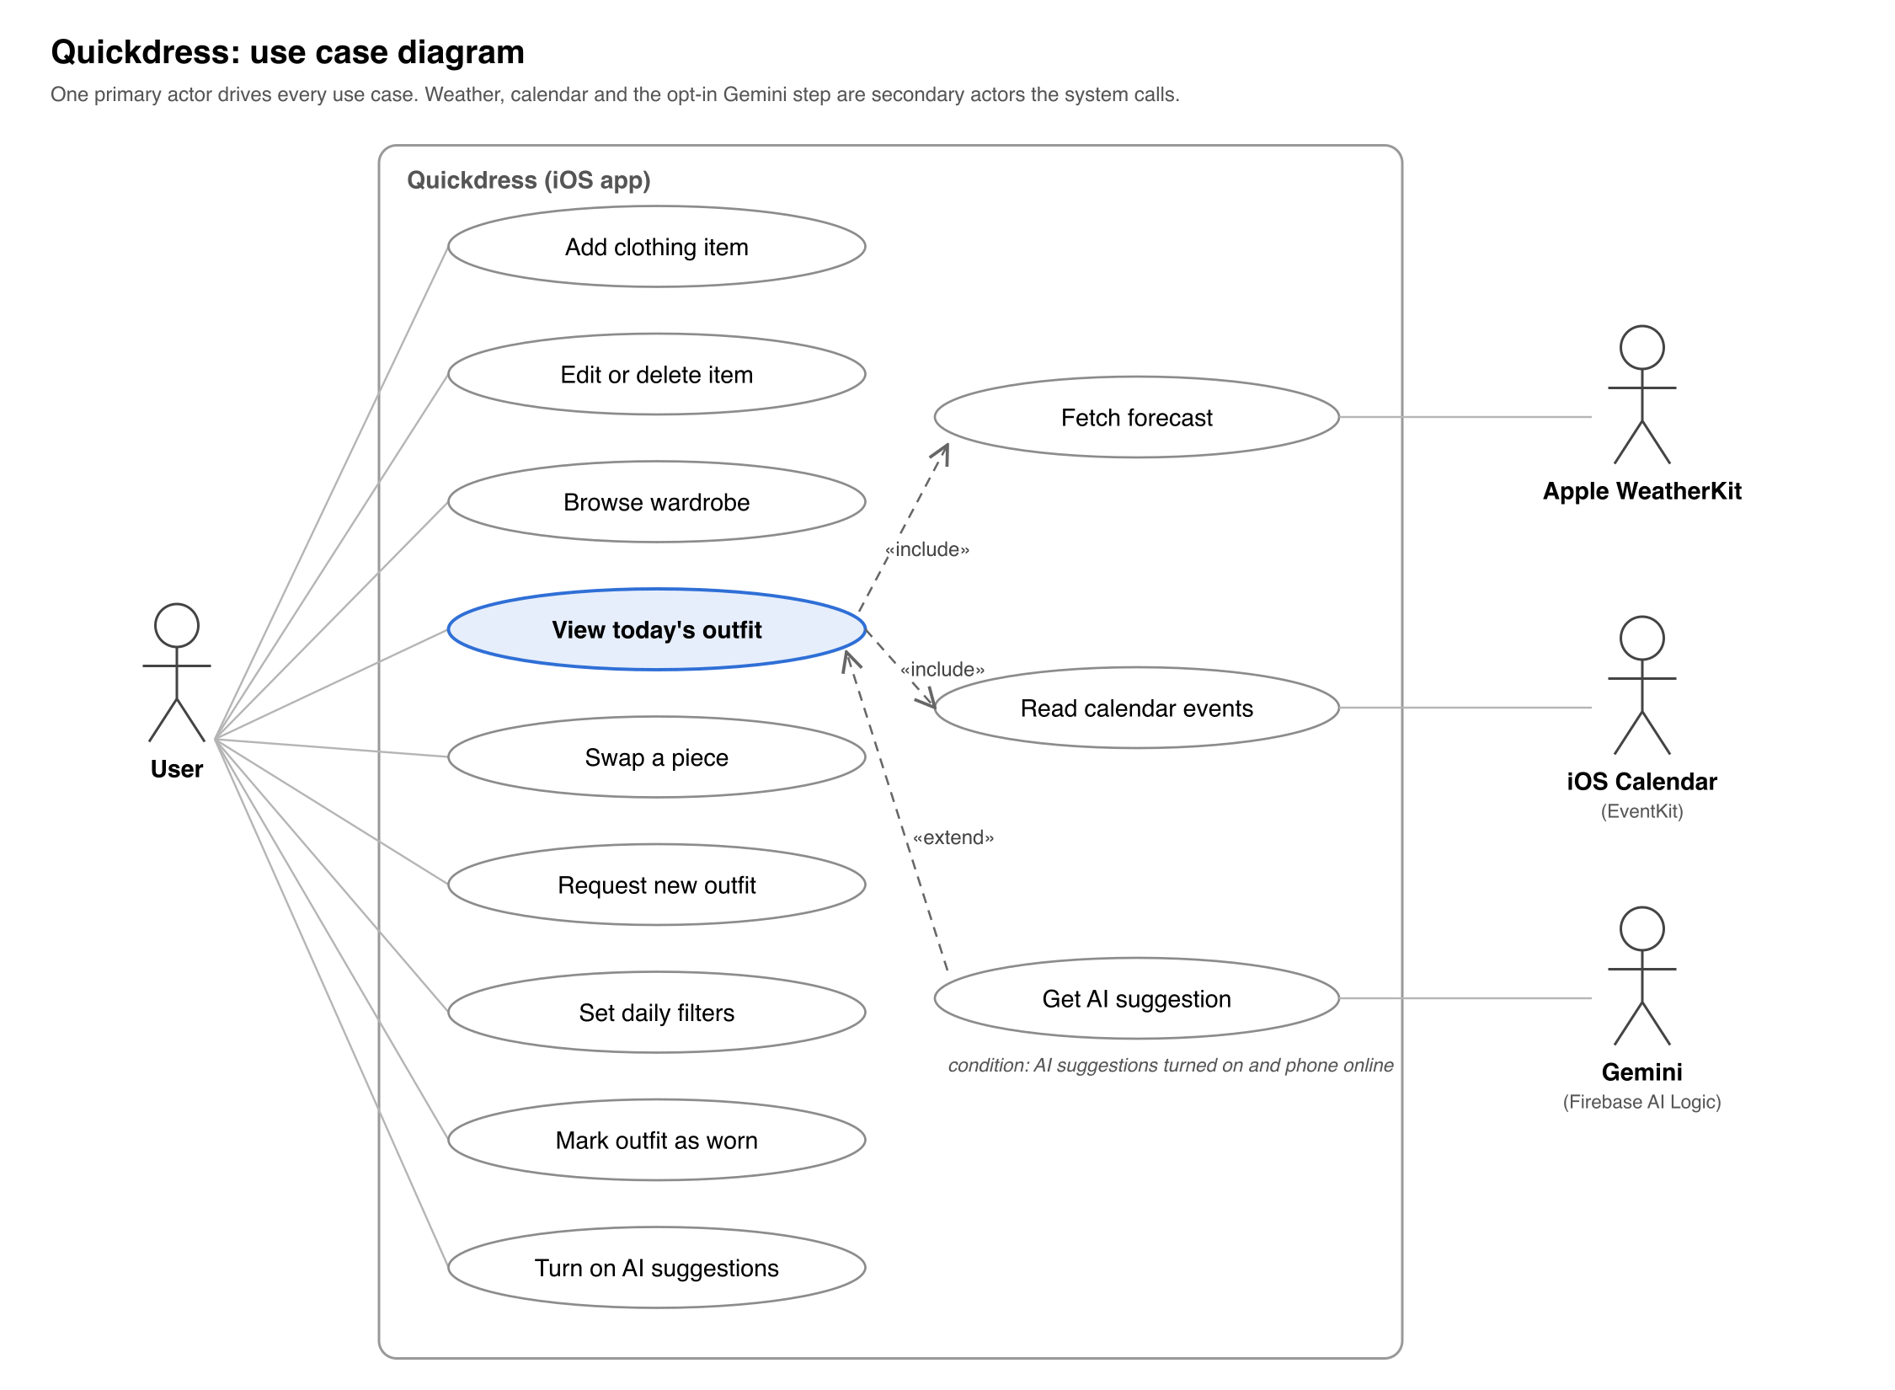
Figure 2. Use case diagram: one primary actor, three secondary actors, twelve use cases.
Viewing today's outfit always includes fetching the forecast and reading calendar events; if either permission is denied the use case still completes with defaults (NFR-07). Getting an AI suggestion extends it only when the user has turned the feature on and the phone is online.

4.1 Use case descriptions
Use case | Actor | Precondition | Main flow | Postcondition | Requirements
Add clothing item | User | Camera or Photos permission granted | 1. User taps Add.  2. Takes or picks a photo.  3. Sets category, colour, warmth, formality, comfort, season.  4. Saves. | Item stored locally with photo and attributes | FR-01, FR-02
Edit or delete item | User | Item exists | 1. User opens an item.  2. Changes attributes or taps Delete.  3. Confirms. | Item updated or removed; outfits containing it are invalidated | FR-03
Browse wardrobe | User | At least one item | 1. User opens Wardrobe.  2. Filters by category or colour.  3. Taps an item for detail. | None | FR-04
View today's outfit | User | At least one top, bottom and pair of shoes stored | 1. App opens on Today.  2. System fetches forecast and calendar (included).  3. Recommender scores combinations and shows the best one. | Outfit of the day displayed and cached | FR-05, FR-08, FR-11, NFR-01
Swap a piece | User | Outfit displayed | 1. User taps a piece.  2. System offers the next best alternatives for that slot.  3. User picks one. | Outfit updated | FR-06
Request new outfit | User | Outfit displayed | 1. User taps New outfit.  2. System generates the next best full combination. | Outfit replaced | FR-07
Set daily filters | User | None | 1. User opens Filters.  2. Sets transport mode, comfort priority, formality override.  3. Applies. | Recommendation regenerated with the filters | FR-10
Mark outfit as worn | User | Outfit displayed | 1. User taps Wearing this. | Outfit logged with today's date; excluded from recommendations for the configured period | FR-09
Turn on AI suggestions | User | None | 1. User opens Settings.  2. Reads what data would be sent.  3. Turns on AI suggestions. | Consent stored; the Gemini step may run when online | FR-22, NFR-02
Fetch forecast | System (WeatherKit) | Location permission granted, network available | 1. System requests today's hourly forecast.  2. Stores it locally. | Forecast cached; last forecast used when offline | FR-08, NFR-03
Read calendar events | System (EventKit) | Calendar permission granted | 1. System reads today's events.  2. Detects formal keywords or user tags. | Formality level for the day set | FR-11
Get AI suggestion | System (Gemini) | AI suggestions on, network available, no answer from the on-device model | 1. System sends anonymised item attributes and the day's conditions.  2. Gemini returns one item per slot.  3. System checks the reply against the wardrobe. | Outfit returned; on any failure the rule-based recommender answers instead | FR-22, NFR-02, NFR-03

5 Global, cultural, social, environmental, economic, public health, safety and welfare considerations
The most significant consideration is privacy: Quickdress holds photographs of a person's clothes, their location and their calendar. Processing everything on the device (NFR-02) is a design decision made because of this, not only for performance.
Area | Consideration | How the requirements respond
Privacy and security | Wardrobe photos, calendar entries and location reveal daily routine and whereabouts. | On-device storage and inference (NFR-02); permissions requested one at a time with an explanation and the app usable without them (NFR-07); no account, no server of our own, no analytics. The only external AI call (FR-22) is off by default and sends anonymised attributes only.
Public health and safety | Dressing for the wrong weather causes discomfort and, in Cairo summers, heat-related risk; morning decision stress is a small daily wellbeing cost. | Weather-driven warmth and outerwear choice (FR-08); one recommendation instead of a catalogue (FR-05) to reduce decision fatigue.
Cultural and social | Dress norms differ by religion, workplace and family; modest dress, hijab-compatible combinations and local occasions (Eid, Ramadan iftars, university events) are common for the target users. The recommender must not impose a single Western style norm. | Formality and comfort are user-defined attributes, not inferred from fashion datasets (FR-02); the user can save their own outfits as examples (FR-12); no body-shape or appearance scoring anywhere in the backlog.
Environmental | Fast fashion is driven partly by people feeling they have nothing to wear. | Recommending only from what the user owns, and tracking what has not been worn (FR-09, FR-15), encourages re-wearing instead of buying.
Economic | Target users are students and early-career professionals with limited budgets. | The app is free, has no in-app purchases, and never links to shopping. Development cost is low: first-party Apple frameworks and no server hosting. WeatherKit needs a paid Apple Developer membership, with free Open-Meteo as a backup, and the opt-in Gemini step uses Google's lowest-cost model.
Global and accessibility | The first release is English-only and iOS-only, which limits reach in Egypt where Android dominates. Colour matching is a real barrier for users with colour-vision deficiency. | Strings externalised for Arabic (NFR-11); VoiceOver and Dynamic Type (NFR-09); colour matching handled by the system so the user never has to judge colours. Android is noted as a future direction, not a requirement.
Public welfare | A recommender that nudges users towards particular clothes could be exploited for advertising. | NFR-02 rules out third-party data sharing without consent, and the scope contains no monetisation feature or commercial recommendations.

6 Conclusion
Quickdress solves a small but daily problem, choosing what to wear, by recommending one outfit from the user's own wardrobe, matched to the weather and the day's calendar. This document fixes the Milestone 1 baseline: a backlog of 22 functional and 11 non-functional requirements, a committed scope of FR-01 to FR-13 and NFR-01 to NFR-08 with FR-22 as a stretch goal, twelve use cases, and a three-sprint plan in which each sprint ends with a demonstrable app. The accompanying Design Specification shows how the MVVM and layered architecture, with the recommender behind a single interface, meets the non-functional requirements committed here. The next delivery is Sprint 1: a working digital wardrobe with capture, editing and browsing.

